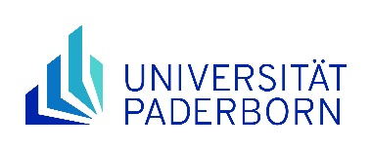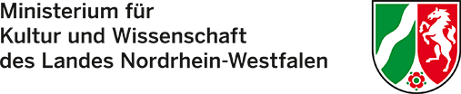

Application and motivation letter for funding under the "NRWege ins Studium" programme

I hereby request
______________________
Surname, first name

__________________ _______________________________
Matriculation number Email (university email, if already available)

a place on the NRWege DSH language course in the

O 1st quarter `26 O 2nd quarter `26 O 3rd quarter `26 O 4th quarter `26
I am currently participating in a "NRWege ins Studium" support programme.: O yes
O no

If you are currently enrolled in a DSH language course at Paderborn University, please indicate your current course (e.g. Mittelstufe II A or Oberstufe B):

I have read the Declaration of consent and I agree that
- my data will be stored for the processing of the application and my participation data (for statistical evaluation purposes and possible queries) will be passed on to the Ministry of Culture and Science in North Rhine-Westphalia (MKW NRW)
- I will participate in at least one further NRWege programme at Paderborn University during the funding period

I further confirm that I have not resided in Germany for more than 5 years and that I obtained my higher education entrance qualification abroad.
The reasons for my application can be found on page 2 of the application in the motivation letter.
IMPORTANT: When applying for NRWege funding, payment of course fees only after refusal!

Paderborn, ________________ _____________________________________
(Date) (Signature)

Please send us the signed application, including the letter of motivation on page 2 and a scan of your current residence document (anonymised except for surname, first name, date/place of birth and § of residence status) as a PDF document to: io-refugees@zv.upb.de

Letter of motivation for the application for funding under the "NRWege ins Studium" programme:
Please provide a brief statement outlining your personal circumstances and explaining why you are unable to finance the course yourself (for example, due to war, displacement or illness). Please also explain why you wish to receive support through the 'NRWege ins Studium' programme. Please do not exceed one page in length!

Paderborn, ________________ _____________________________________
(Date) (Signature)

